WEBSITE CONTENT
HOME
Title:
Welcome to the Municipality of Binalonan
Content:
The Municipality of Binalonan, located in Pangasinan, is committed to delivering efficient, transparent, and people-centered public service. With a strong dedication to community development, innovation, and good governance, we strive to improve the quality of life for all our residents. Explore our services, stay updated with the latest news, and discover what makes Binalonan a progressive and vibrant municipality.
ABOUT
Title:
About Binalonan
Content:
Binalonan is a first-class municipality in the province of Pangasinan, Philippines. Known for its rich cultural heritage and dynamic local economy, the municipality continues to grow through infrastructure development, education programs, and community initiatives. The local government is committed to transparency, accountability, and inclusive growth, ensuring that every citizen benefits from sustainable progress.
SERVICES
Title:
Our Services
Content:
Civil Registry
Provides official documents such as birth, marriage, and death certificates to residents.
Business Permits
Handles business registration, renewal, and licensing to support local entrepreneurs.
Health Services
Offers medical assistance, health programs, and community wellness initiatives.
Education Support
Provides scholarship programs, educational assistance, and school partnerships.

NEWS
Title:
Latest News & Updates
Content:
Binalonan Foundation Day Celebration
Celebrate the rich culture and heritage of Binalonan with exciting events, performances, and activities for the whole community.
Infrastructure Development Updates
The municipality continues to improve road networks and public facilities to better serve residents.
Community Outreach Programs
Various programs are conducted to support families, promote health awareness, and strengthen community engagement.

GALLERY
Title:
Community Highlights
Content:
Explore videos and highlights showcasing the municipality’s events, infrastructure projects, and community programs. These reflect the unity, progress, and active participation of Binalonan residents.
CONTACT
Title:
Contact Us
Content:
Municipal Hall, Poblacion
Binalonan, Pangasinan 2433
Phone: (075) 123-4567
Email: info@binalonan.gov.ph
Office Hours: Monday to Friday, 8:00 AM – 5:00 PM
Stay connected with us through our official social media pages for updates and announcements.

SUGGESTED IMAGES / MEDIA
Use these keywords:
Hero Section
- "Binalonan Pangasinan town hall"
- "Binalonan fountain night"
ABOUT SECTION
About Binalonan
Binalonan is a 1st class municipality in the province of Pangasinan, Philippines. Known for its rich history, vibrant culture, and progressive development.

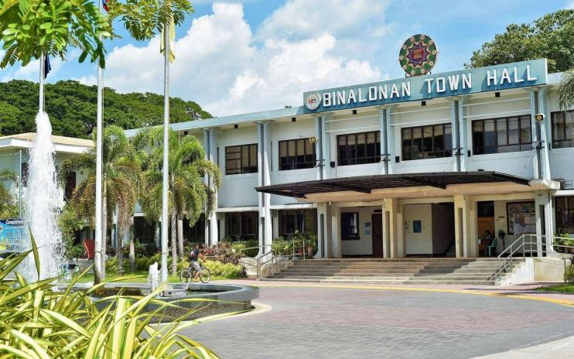
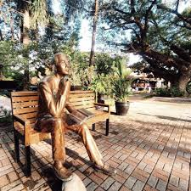
Our History
Discover the rich heritage and historical significance of Binalonan.


Our People
Meet the warm and welcoming community of Binalonan.

Our Progress
See our achievements and ongoing development projects.

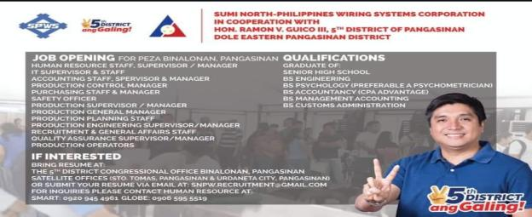

OUR SERVICE
Civil Registry
Birth, marriage, and death certificates

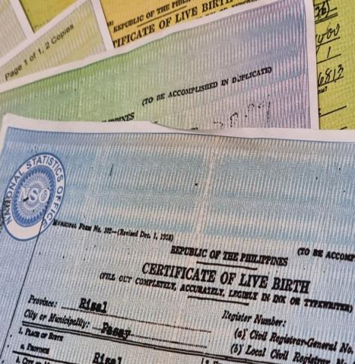
Business Permits
Business permit and license applications

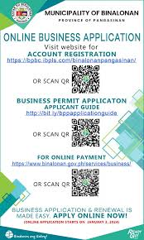
Health Services
Medical assistance and health programs

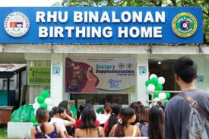
Education
Scholarship programs and school support


LATEST NEWS & UPDATE
Binalonan Foundation Day Celebration
December 15, 2024
Join us for the annual foundation day celebration with cultural shows and activities.

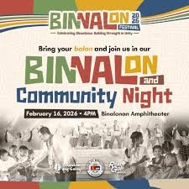
New Road Network Completed
December 10, 2024
20 kilometers of new roads now serving Binalonan residents.

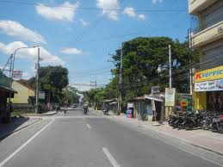
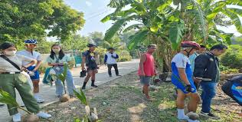
Christmas Gift Giving Program
December 20, 2024
Thousands of families to receive holiday assistance.

Video Ideas
Search for:
- “Binalonan Pangasinan vlog”
- “Pangasinan town development”
- “Barangay outreach Philippines”

